# **Exercise 7: Integrated Analysis - K-means Clustering using Tableau & R**

**As you proceed with the assignment, follow the written instructions. Screenshots are provided ONLY as a reference.**

**Make sure you submit all screenshots with a clearly visible menu bar including the date and timestamp.**

**Note: You must use the following conventions to name objects/systems created in this exercise.**

**Objective:-**  The objective of this exercise is to get a hands-on experience K-means clustering analysis using R and visualizing results through Tableau.

Below are the objectives of the exercise

1) Data retrieval

2) Data pre-processing

3) K-mean clustering

4) Tableau- R integration by invoking Rserve ()

**1) Data Retrieval**

1. Open a new project in R studio using the below screenshots

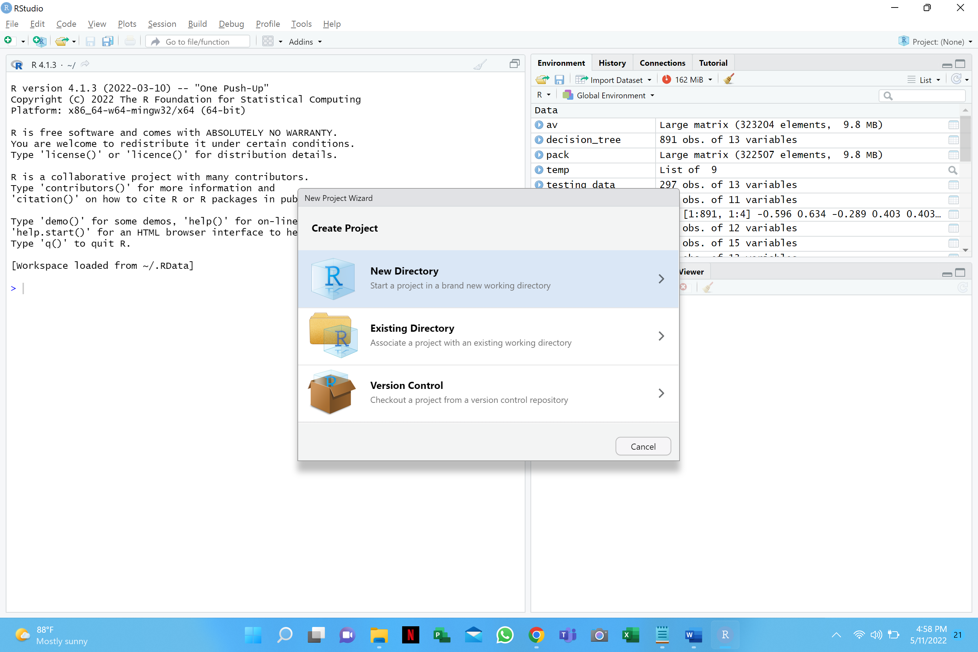

1. Select New Project

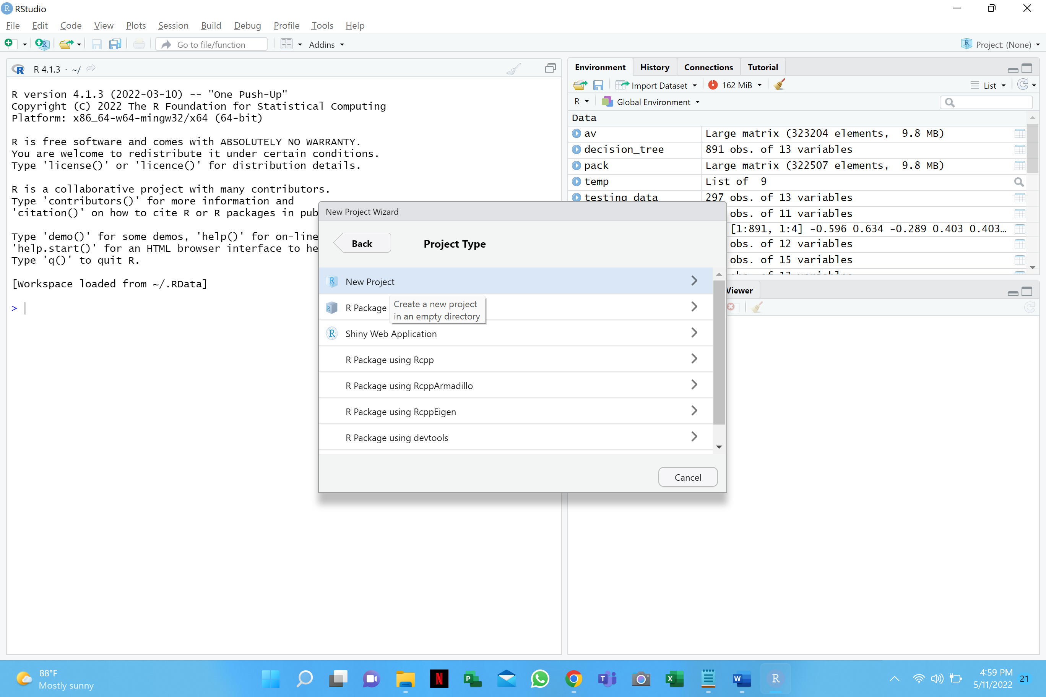

1. Name this directory to Kmean and browse the folder you are working in.

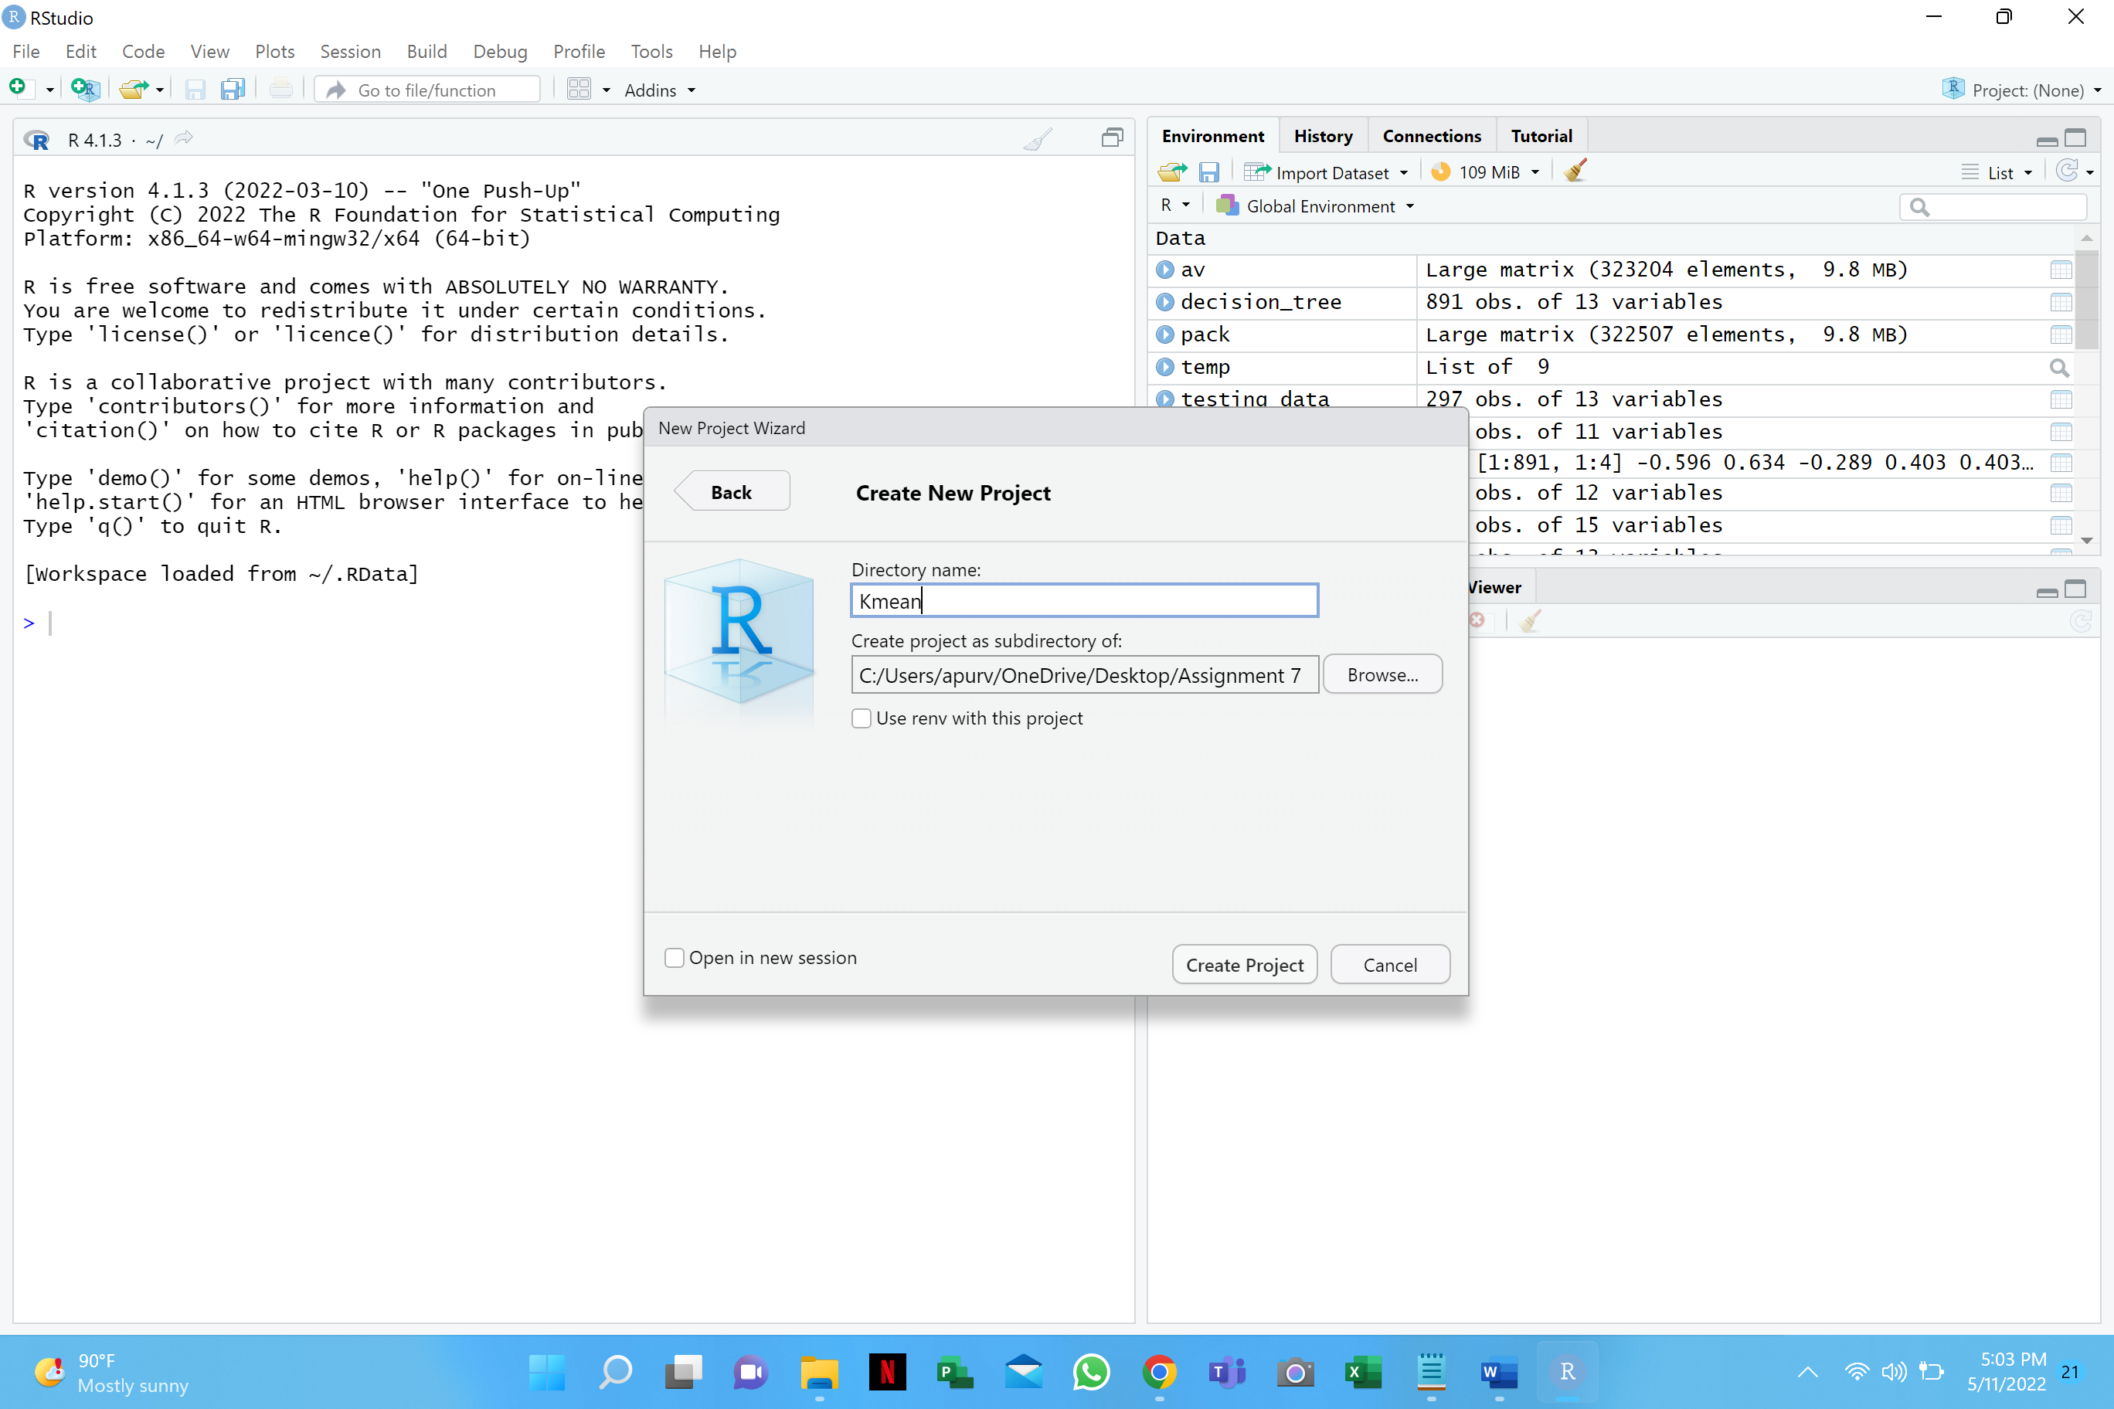

4. Create the new project by clicking on the ‘Create Project’ in this new working directory and allow it to process for a minute.

5. Create a new R script (go to File -> New File -> R Script) and save it as **KmeanFirstNameLastName.R (replace FirstNameLastName by your FirstName LastName)** in the Kmean folder.

6. Place the titanic.csv file in the Kmean folder created in step 3

7. Read the csv file in the object called titanic as mentioned below.



**Make sure your titanic file is in the Kmean folder

The dataset is now in titanic data frame

8. Execute the command to check the number of rows and columns as mentioned below.

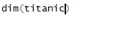

**Q1) Write the output of the above executed command.**

**Answer:**

**2) Data Pre-processing**

This steps involves replacing missing value of the ages with their mean, adding age category column and replacing the label with a meaningful name

1. Execute the below command to calculate the average age of the passengers using the below snapshot



**Q2) What is the average age that you get?**

**Answer:**

2. Execute the below commands to round off the age to their nearest integer. 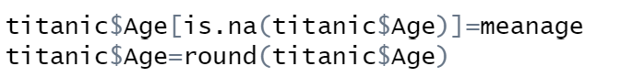

3. Create a new variable (vector) called Age Category and assign a category to every passenger in the dataset.

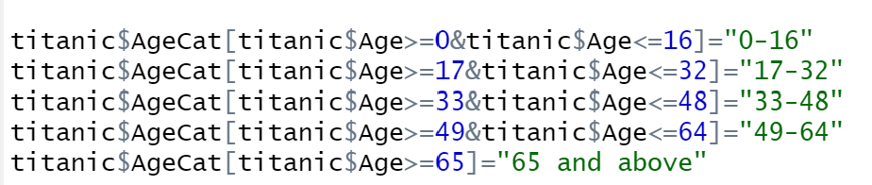

4. Replace the integer value of 0 and 1 in the survivor variable (vector) with a meaningful labels.



5. Convert the integer and character vectors to factor variables as mentioned in the screenshot for the other variables

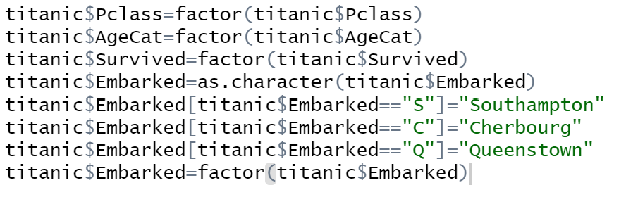

6. Remove the other redundant variables such as Ticket and Cabin from the titanic data frame.



7. Crosscheck the processed values using the command as mentioned below.



**Q3) Paste the screenshot of the above executed command.**

**Answer:**

**8. Save the processed titanic dataset**



**3) K-means Clustering**

1. Three important categorical variables in the titanic dataset are

1. Survived
2. Sex
3. Embarked

Execute the below command to convert the above 3 categorical variables into continuous. The below code would create 3 new variables of type continuous and save them in the new file “titanicUpdated.csv”.

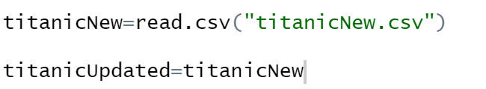



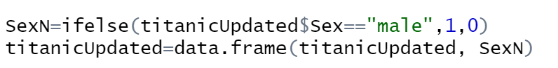





***Before the cluster analysis one has to select for the optimum number of clusters.***

2. Execute the below command to normalize the data and find the total number of clusters required.

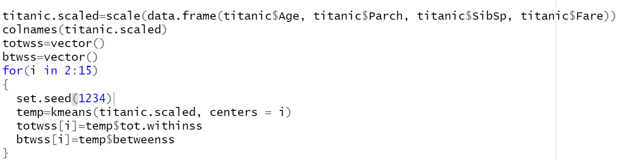

3. Plot the two graphs using the code below



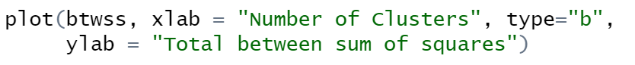

**Q4) Paste the screenshot of the two plot**

**Answer:**

**Q5) Write the desired number of cluster you selected for the analysis**

**Answer**:

**(Hint:** We need to keep adding clusters to the point where further addition of cluster won’t do much of explanation of the variation. **This is also the point where the slope of the curve changes suddenly and gives an angle to the graph**)

Now that ***we know what the optimum number of clusters to be used in our integrated analysis what clustering variables are important***? In the next section you will perform visual analysis integrating Tableau with R to visualize the clusters in Tableau.

**4) TABLEAU / R INTEGRATION**

You will have already used Tableau for previous assignments. In this part of the exercise we will

leverage the modeling power of R along with the visualization power of Tableau to perform our

exercise in integrated analysis.

**Step 1: Initiate Rserve and Making Connection**

Type the following code on your R window

install.packages('Rserve',,'http://www.rforge.net/')

library(Rserve)

Rserve()

For mac users:

To start Rserve in Macs, we need to pass arguments to the Rserve() function.

Rserve(args = "--save")

In order for us to be able to make a connection between Tableau and R, we need to do it through Rserve. Rserve itself is the server that is a program that responds to requests from clients. It listens for any incoming connections and processes incoming requests.

1. Open Tableau
2. Go to the Help menu and select Settings and Performance and then “Manage Analytics Extension Connection”.
3. Enter a server name of “Localhost” (or “127.0.0.1”) and a port of “6311”.
4. Click on the “Test Connection” button to make sure everything runs smoothly. You should see a successful message. Click OK to close.

**Step 2: Open the titanicUpdated.csv file on Tableau**

Open the file “titanicUpdated.csv” as text file on Tableau. Save your Tableau file as TitanicViz-Student Name.twbx (replace student name with your full name)

**Note: Save it with .twbx file extension**

On the “Data Source” tab on Tableau please select the Connection as “Extract”. Screenshot is shown below for reference.

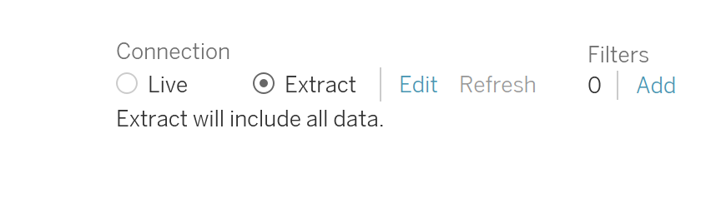

**Step 3: Forming Clusters**

Click on the New Worksheet in Tableau. On this worksheet you would see all the dimensions and measures in your current dataset represented in Tableau.

**Q6) Paste a screenshot of the current set of tables.**

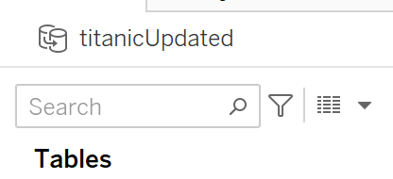

Ensure that the variables “Embarked N”, “Sex N” and “Survived Num” shows with Age, Fare, Parch, Pclass etc.

**Answer:**

**Parameter Creation:**

Right click on the empty space within the tables window and select “Create Parameter”. Name the parameter as “# of Clusters”. Select the data type as Integer and enter the “*Ideal number of Clusters*”

that you obtained as part of this exercise under Current value cell. Radio button for “All” would be

enabled under allowable values. Take a screenshot once you populate all fields of this parameter.

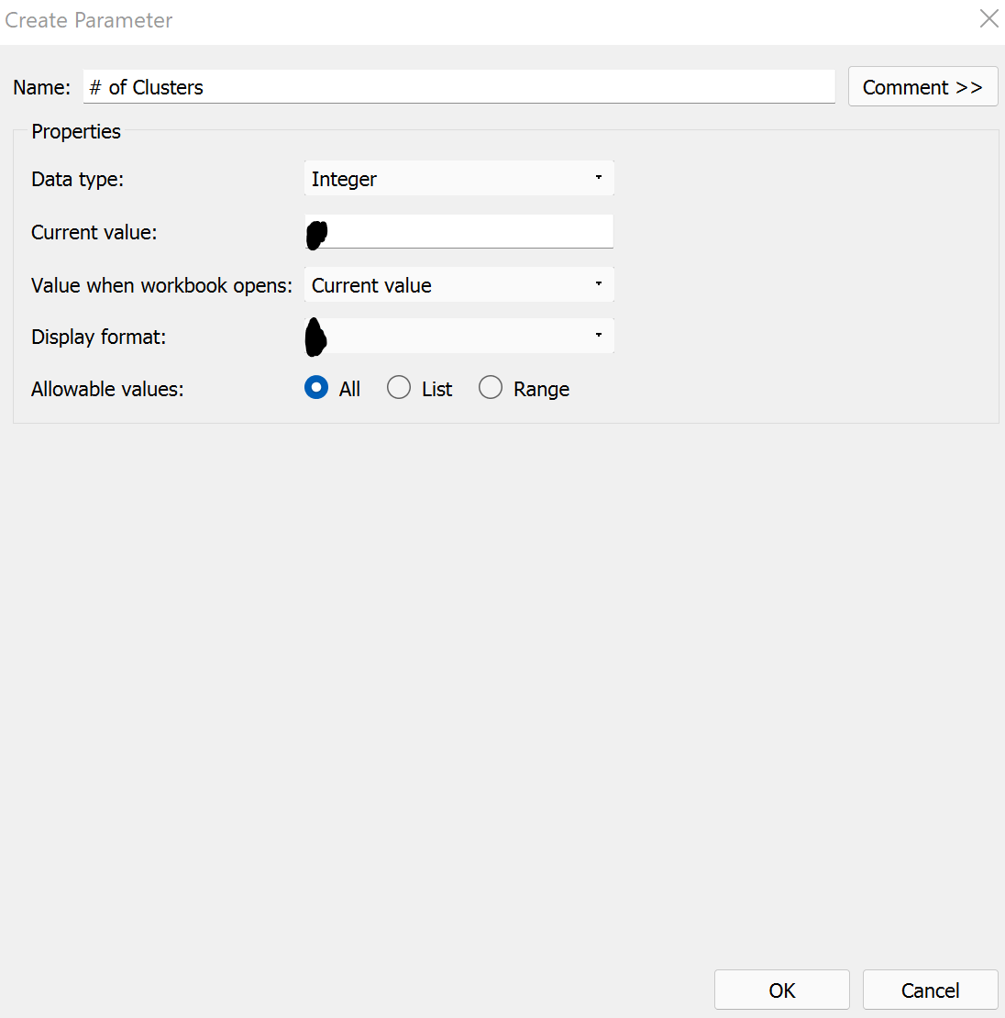

**Q7) Please paste screenshot once you populate all fields for this parameter.**

**Answer:**

Similarly create another parameter called “Seed”, data type integer, and set the value as 1234. Now you would see two parameters under your parameter window of your worksheet.

**Q8) Paste a screenshot once you populate all fields for this “Seed” parameter.**

**Answer:**

**Calculated Field creation:**

1. Right click on the empty space within the tables window and select “Create Calculated Field”.
2. In the window that opens up, type the name as “Cluster” and type the below piece of code

within the window and click OK.

Script_INT("

## Sets the seed

set.seed(.arg8[1])

## Studentizes the variables

age<-(.arg1-mean(.arg1))/sd(.arg1)

pclass<-(.arg2-mean(.arg2))/sd(.arg2)

embarkedn<-(.arg3-mean(.arg3))/sd(.arg3)

sex<-(.arg4-mean(.arg4))/sd(.arg4)

survived<-(.arg5-mean(.arg5))/sd(.arg5)

sibsp<-(.arg6-mean(.arg6))/sd(.arg6)

dat<-cbind(age,pclass,embarkedn,sex,survived,sibsp)

num<-.arg7[1]

## Creates the clusters

kmeans(dat,num)$cluster

",

SUM([Age]),SUM([Pclass]),SUM([EmbarkedN]),SUM([SexN]),SUM([SurvivedNum]),SUM([Sib Sp]),[# of Clusters],[Seed])

Note: The highlighted part that you see above are the actual variable names used in your dataset. If your dataset has any other names for those measures, please use those names here, else you would

see an error. Also, there may be a parsing error later while dragging ‘cluster’ to columns field. To tackle this, please type this calculated field code as there may be a parsing error while copying from MS Word to Tableau.

**Step 4: Visualization of Key variables across Clusters**

Objective: The objective of this step is to visualize how different variables vary across different cluster.

MAKE SURE YOU USE BAR CHARTS FOR ALL VISUALIZATIONS EXCEPT FOR THE FIRST VISIULATION.

***Step 4.1: Overall Clusters***

1. Name the worksheet “Overall Clusters”. As you configure the sheet, click on the x to ignore the screen errors.
2. Click on the Analysis menu path and delselect (turn off) the Aggregate Measures selection.

1. Drag the Cluster field to the Columns shelf. Ensure the Cluster is set to Discrete.

1. Drag the Survived field to the Columns shelf. Make sure the Survived field is set to attribute.

1. Pull the other variables SexN, Age, Pclass, EmbarkedN and SibSp on to the rows field.
2. Click on “Box and Whisker plot” from the ShowMe tab.
3. Drag “Embarked” field from Dimensions to Color. Right click it and convert it to an attribute. Make sure it is set to discrete.
4. Make sure the “Cluster” variable is set to Discrete and Survived field is set to attribute. These two fields will appear in blue under Columns tab.
5. Ensure the sequence of the field is as below:



1. Go to worksheet – Show Title. Add your name to the title.

**Q9) Paste the screenshot of the worksheet “Overall Clusters” below**

**Answer:**

**Q10) Provide your insights from cluster 1.**

**Answer:**

**Q11) Provide your insights from cluster 4.**

**Answer:**

**Key Takeaway:** The key takeaway from this worksheet is that Sex is the most important variable in the formation of cluster as most of the clusters have predominantly one gender.

***Step 4.2 : Survival by Cluster***

Objective: The objective of this sheet is to see which clusters have highest survivability.

Task:

1. Click on new Worksheet and name it “Survival by Cluster”. As you configure the sheet, click on the x to ignore the screen errors.
2. Click on the Analysis menu path and delselect (turn off) the Aggregate Measures selection.

1. Drag the Cluster field to the Columns shelf. Ensure the Cluster is set to Discrete.

1. Drag the Survived field to the Columns shelf on left of cluster. Make sure the Survived field is set to attribute.

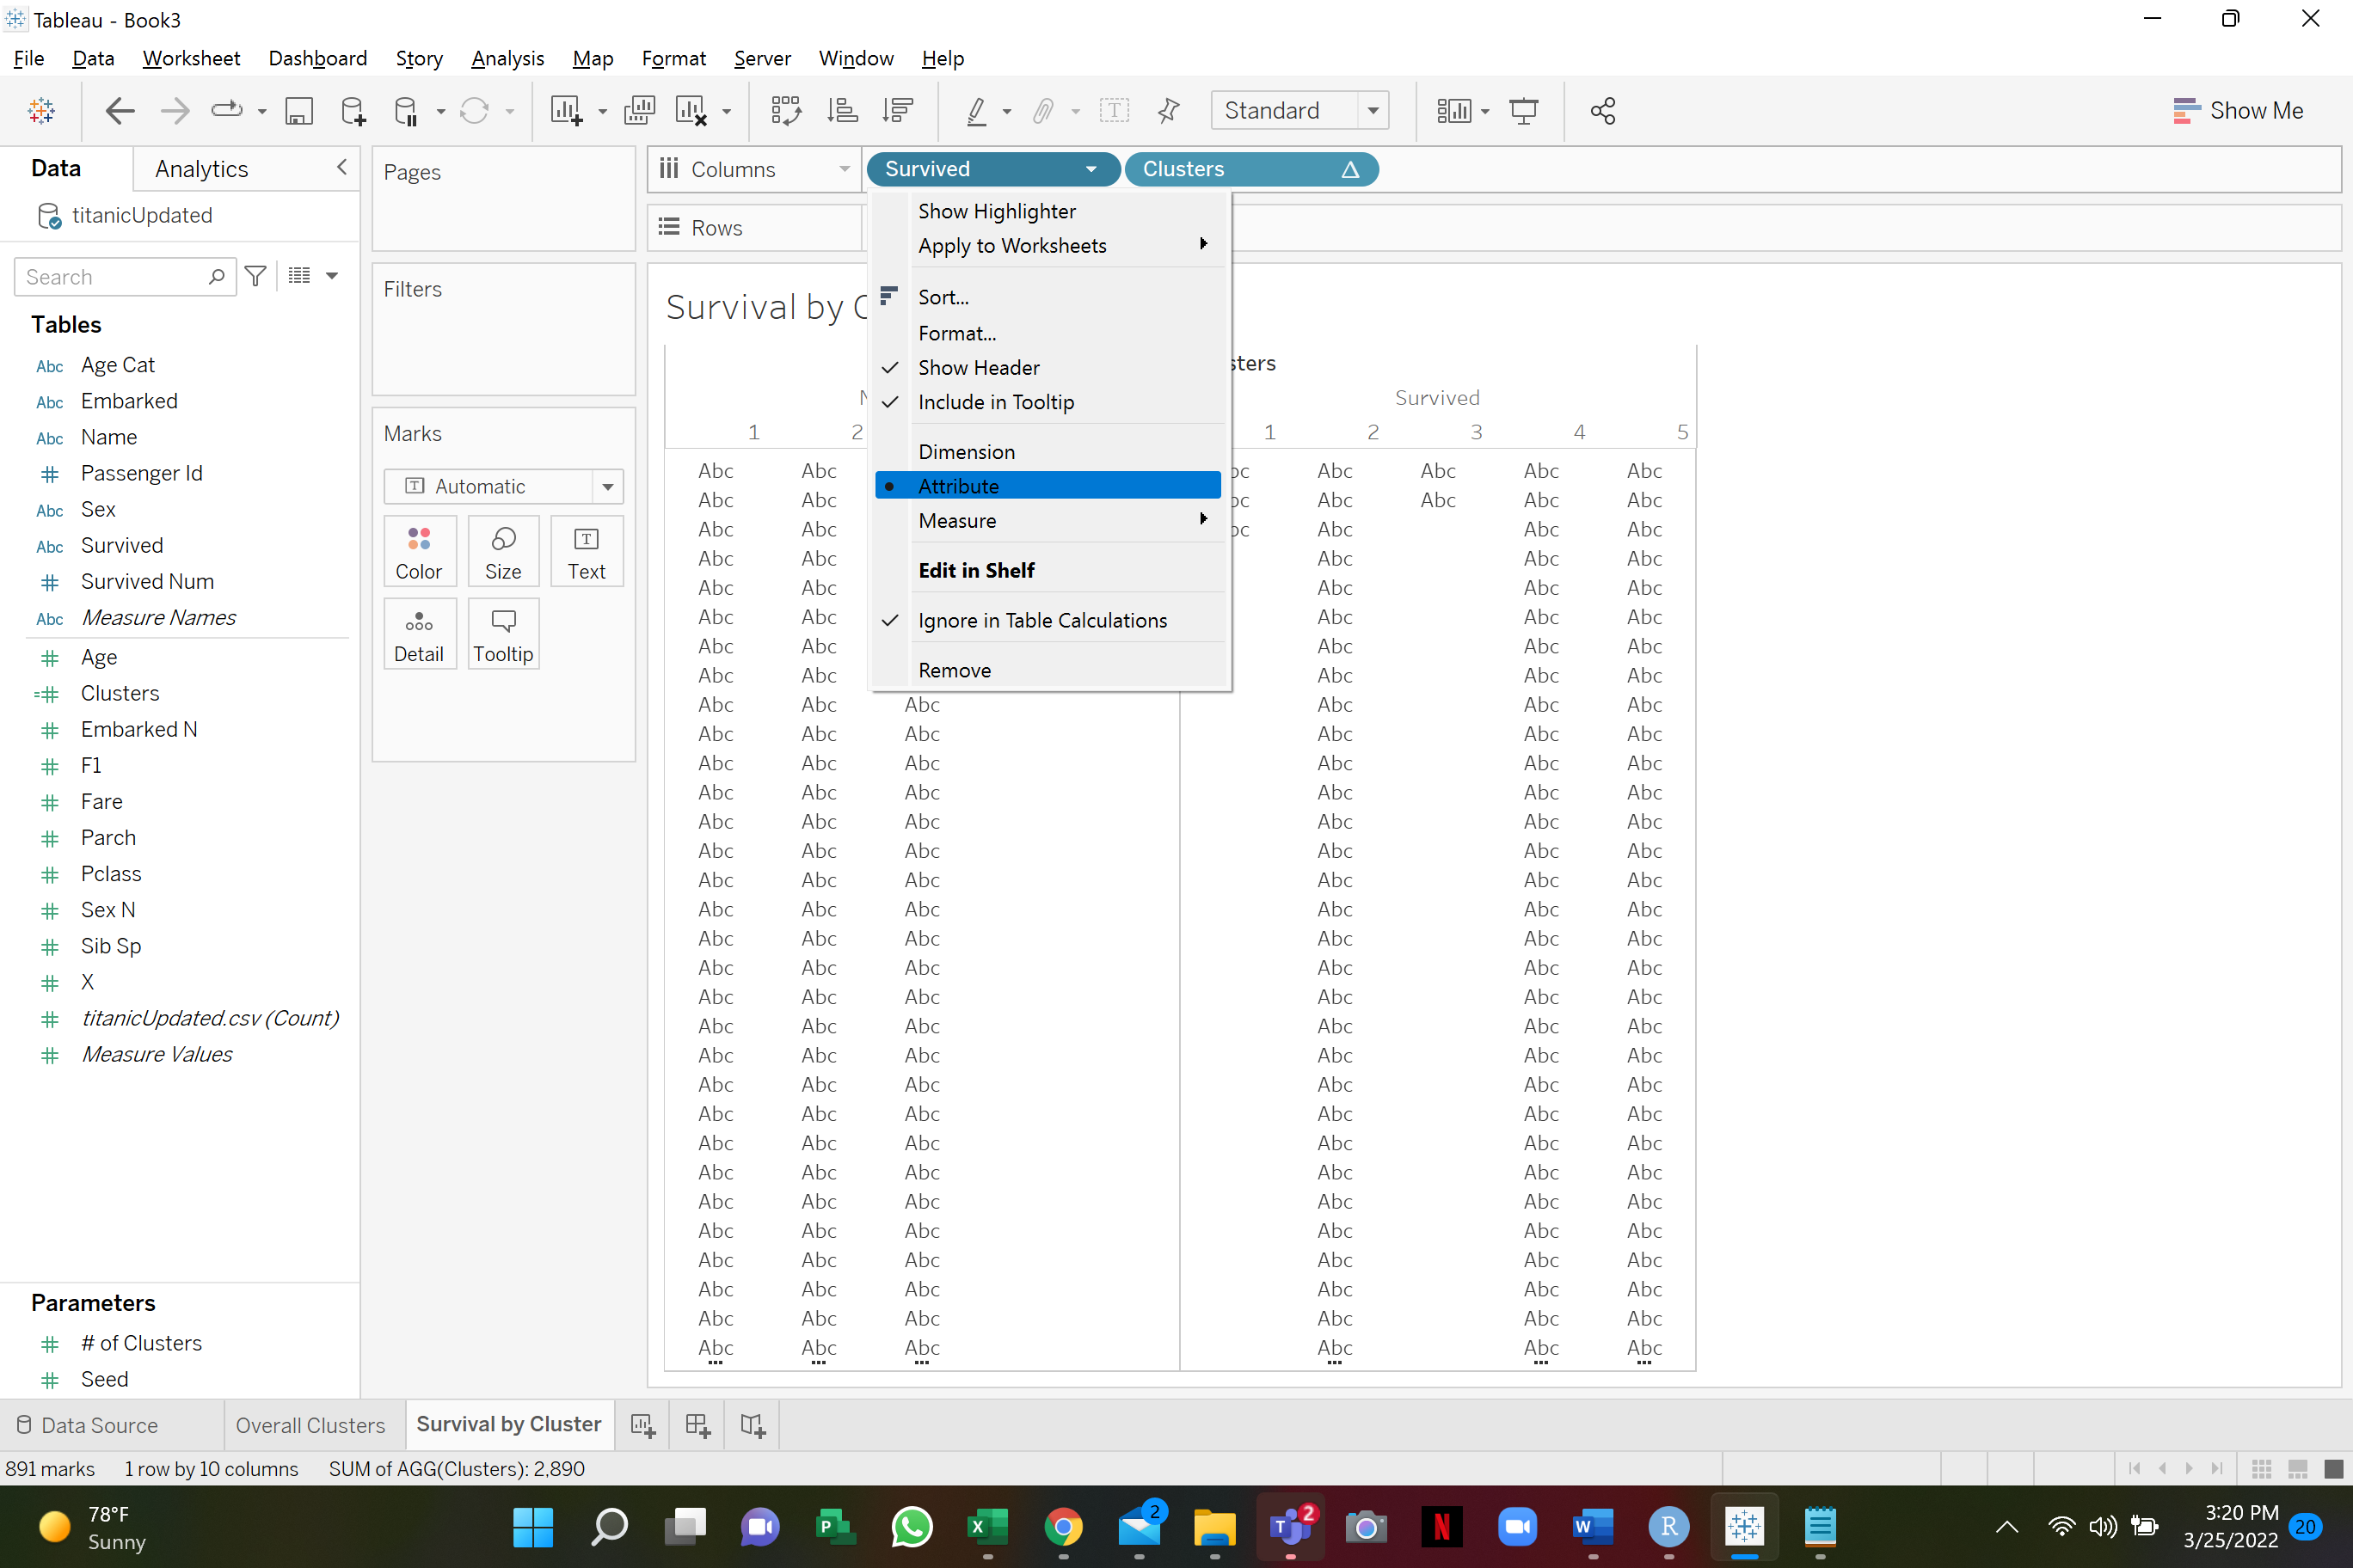

1. Drag the “titanicUpdated.csv(Count)” variable to rows.
2. Select horizontal bar chart as visualization.
3. Also, select the variable “Survived” to Color section under “Marks” pane. Right click it and convert it to an attribute.
4. Ensure the sequence of the field is as shown below:

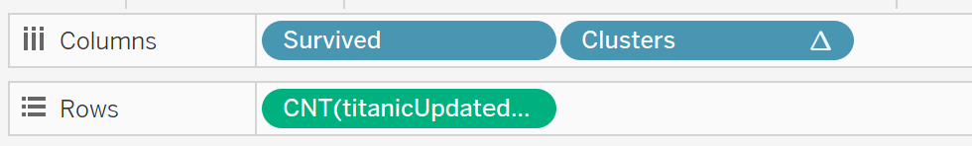

Note: The visualization should be a bar chart

1. Go to worksheet – Show Title. Add your name to the title.
2. Right click on the vertical axis and select “Add reference line”
3. On the “Add Reference Line” screen, select Scope as “Entire table”, Value = “CNT(titanicUpdated.csv)” and “average” and click OK.

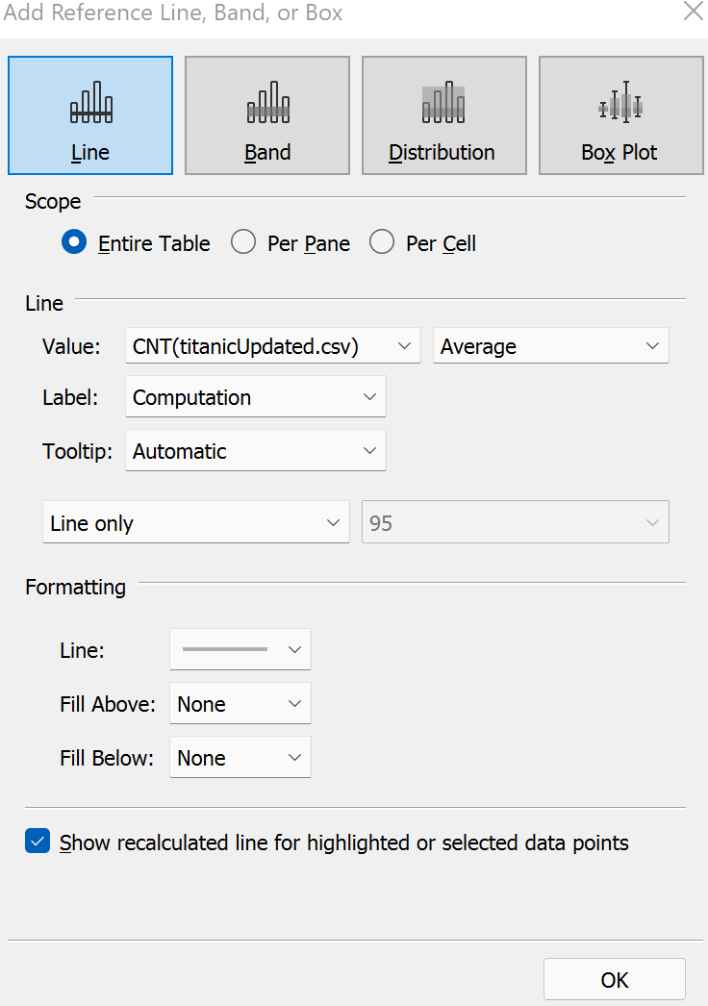

**Q 12) Paste the screenshot of your worksheet. Ensure that you have added a Title and your name is contained in the title. Titles without names shall not be considered for grading.**

**Answer:**

**Q 13) From the bar chart, could you name two clusters where survivability is the highest?**

**Answer:**

Going forward for our analysis, our focus would be on these two clusters.

**Q 14) Enter the top two clusters you’ve identified and enter them against <Cluster 1> and <Cluster 2>. Leave the other rows blank for now.**

|  |  |  |
| --- | --- | --- |
|  | <Cluster 1> | <Cluster 2> |
| Ideal Gender |  |  |
| Ideal Passenger Class |  |  |
| Ideal Age Category |  |  |
| Ideal Embarked point |  |  |
| Ideal number of siblings |  |  |

**Key Takeaway:** The key takeaway from the above worksheet “**Survival by Cluster**” is that **only in case of two clusters**, the number of passengers survived either outweigh or compare to the number of passengers who didn’t survive. Hence these clusters form the most important cluster for our analysis.

***Step 4.3: Survival by Gender***

Objective: The objective of this section is to understand which is the best gender from a survivability perspective, in each of our top two clusters, identified in the previous step.

Task:

1. Click on new Worksheet and name it “Survival by Gender”. As you configure the sheet, click on the x to ignore the screen errors.
2. Click on the Analysis menu path and deselect (turn off) the Aggregate Measures selection.

1. Drag the Cluster field to the Columns shelf. Ensure the Cluster is set to Discrete.

1. Drag the Survived field to the Columns shelf. Make sure the Survived field is set to attribute.

1. Select titanUpdated.csv(Count) in the rows
2. Drag “Sex” to Color section under Marks pane. Right click it and convert it to an attribute
3. Ensure the sequence of the field is as shown below:

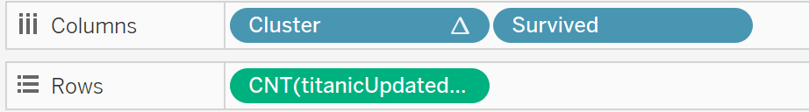

Note: The visualization should be a bar chart

1. Go to worksheet – Show Title. Add your name to the title.

**Q15) Paste your screenshot of the Tableau worksheet below. Make sure it carries the Title with your name.**

**Answer:**

**Q16) If you are Female, which cluster should you belong, to ensure higher probability of survival?**

**Answer:**

**Q17) Based on your findings, enter the ideal Gender (that has the best chance to survive) in your top two cluster. (Keep filling all the rows serially)**

|  |  |  |
| --- | --- | --- |
|  | <Cluster 1> | <Cluster 2> |
| Ideal Gender | <Enter the gender that has the best survivability in this cluster> | <Enter the gender that has the best survivability in this cluster> |
| Ideal Passenger Class |  |  |
| Ideal Age Category |  |  |
| Ideal Embarked point |  |  |
| Ideal number of siblings |  |  |

**Key Takeaway:** The key takeaway from the above worksheet “**Survival by Gender**” is that in the two prominent clusters that we identified in previous steps; one gender clearly dominates the survivability. Note that cluster 1 is comprised of only male passengers.

***Step 4.4: Survival by Passenger Class***

Objective: The objective of this section is to understand which is the best gender/class combination from a survivability perspective, in each of our top two clusters.

Task:

1. Click on new Worksheet and name it “Survival by Passenger Class”. As you configure the sheet, click on the x to ignore the screen errors.
2. Click on the Analysis menu path and delselect (turn off) the Aggregate Measures selection.

1. Drag the Cluster field to the Columns shelf. Ensure the Cluster is set to Discrete.

1. Drag the Survived field to the Columns shelf. Make sure the Survived field is set to attribute.

1. Select Sex and titanUpdated.csv(Count) in the rows. Sex should be attribute.
2. Drag “Pclass” to Color section under Marks pane. Right click it and convert it to an attribute. Make sure it is set to discrete.
3. Ensure the sequence of the field is as shown below

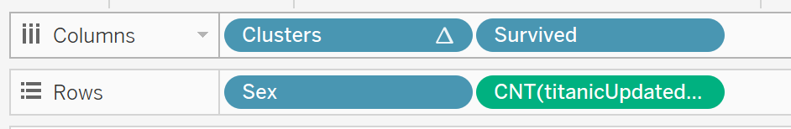

Note: The visualization should be a bar chart

1. Go to worksheet – Show Title. Add your name to the title.

**Q18) Paste your screenshot of the Tableau worksheet below. Ensure you have the title with your name on it.**

**Answer:**

**Q19) Based on your findings, enter the ideal Gender/Passenger Class (that has the best chance to survive) in your top two cluster. (Keep filling all the rows serially. Data should be filled for all previous rows)**

|  |  |  |
| --- | --- | --- |
|  | <Cluster 1> | <Cluster 2> |
| Ideal Gender |  |  |
| Ideal Passenger Class | <Please write the ideal class for the gender in above cell and above cluster.> | <Please write the ideal class for the gender in above cell and above cluster.> |
| Ideal Age Category |  |  |
| Ideal Embarked point |  |  |
| Ideal number of siblings |  |  |

**Key Takeaway:** The key takeaway from the above worksheet “**Survival by Passenger class**” is that in some key clusters, most of the survivors belonged to a particular class.

***Step 4.5: Survival by Age Category***

Objective: The objective of this section is to understand which is the best gender/age category combination from a survivability perspective, in each of our top two clusters.

Task:

1. Click on new Worksheet and name it “Survival by Age Category”. As you configure the sheet, click on the x to ignore the screen errors.
2. Click on the Analysis menu path and delselect (turn off) the Aggregate Measures selection.

1. Drag the Cluster field to the Columns shelf. Ensure the Cluster is set to Discrete.

1. Drag the Survived field to the Columns shelf. Make sure the Survived field is set to attribute.

1. Select Sex and titanUpdated.csv(Count) in the rows. Sex should be attribute.
2. Drag Age Category (Age Cat) to Color section under Marks pane. Right click it and convert it to an attribute.
3. Ensure the sequence of the field is as shown below



Note: The visualization should be a bar chart

1. Go to worksheet – Show Title. Add your name to the title.

**Q20) Paste your screenshot of the Tableau worksheet below. Ensure you add the title with your name.**

**Answer:**

**Q21) : Based on your findings, enter the ideal Gender/Age Category Class (that has the best chance to survive) in your top two cluster. (keep filling all the rows serially. Data should be filled for all previous rows)**

|  |  |  |
| --- | --- | --- |
|  | <Cluster 1> | <Cluster 2> |
| Ideal Gender |  |  |
| Ideal Passenger Class |  |  |
| Ideal Age Category | <Please write the ideal age category for the gender in above cell and above cluster.> | <Please write the ideal age category for the gender in above cell and above cluster.> |
| Ideal Embarked point |  |  |
| Ideal number of siblings |  |  |

**Key Takeaway:** Most of the female survivors were from the age category 17-32 years. Most men who survived in cluster 1 also belonged to the age category 17-32 years. Overall, we can say that because majority of the passengers seem to fall it the age group 17-32 years their survivability salience is high.

***Step 4.6: Survival by Embarked Point***

Objective: The objective of this section is to understand which is the best gender/embarked point combination from a survivability perspective, in each of the top two clusters.

Task:

1. Click on new Worksheet and name it “Survival by Embarked Point”. As you configure the sheet, click on the x to ignore the screen errors.
2. Click on the Analysis menu path and delselect (turn off) the Aggregate Measures selection.

1. Drag the Cluster field to the Columns shelf. Ensure the Cluster is set to Discrete.

1. Drag the Survived field to the Columns shelf. Make sure the Survived field is set to attribute.

1. Select Sex and titanUpdated.csv(Count) in the rows. Sex should be attribute.
2. Drag Embarked variable to Color section under Marks pane. Right click it and convert it to an attribute.

Note: The visualization should be a bar chart

1. Ensure the sequence of the field is as shown below



1. Go to worksheet – Show Title. Add your name to the title.

**Q22) Paste your screenshot of the Tableau worksheet below. Ensure you have the title added with your name.**

**Answer:**

**Q23) Output: Based on your findings, enter the ideal Gender/Embarked point (that has the best chance to survive) in your top two cluster. (keep filling all the rows serially. Data should be filled for all previous rows)**

|  |  |  |
| --- | --- | --- |
|  | <Cluster 1> | <Cluster 2> |
| Ideal Gender |  |  |
| Ideal Passenger Class |  |  |
| Ideal Age Category |  |  |
| Ideal Embarked point | <Please write the embarked point for the gender in above cell and above cluster.> | <Please write the embarked point for the gender in above cell and above cluster.> |
| Ideal number of siblings |  |  |

**Key Takeaway:** Most of the passengers embarked from Southampton. Amongst the survivors, majority of the passengers were from Southampton.

***Step 4.7: Survival by number of Siblings***

Objective: The objective of this section is to understand which is the best gender/# of sibling’s combination from a survivability perspective, in each of the top two clusters.

Task:

1. Click on new Worksheet and name it “Survival by number of Siblings”. As you configure the sheet, click on the x to ignore the screen errors.
2. Click on the Analysis menu path and delselect (turn off) the Aggregate Measures selection.

1. Drag the Cluster field to the Columns shelf. Ensure the Cluster is set to Discrete.

1. Drag the Survived field to the Columns shelf. Make sure the Survived field is set to attribute.

1. Select Sex and titanUpdated.csv(Count) in the rows. Sex should be attribute.
2. Ensure the sequence of the field is as shown below



1. Drag Sib Sp (Measure) to Color section under Marks pane. Right click it and convert it to an attribute. Make sure it is discrete.

Note: The visualization should be a bar chart

1. Go to worksheet – Show Title. Add your name to the title.

**Q24) Paste your screenshot of the Tableau worksheet below. Ensure you have the title with your name on it.**

**Answer:**

**Q25) Output: Based on your findings, enter the ideal Gender/# of Sib Sp (that has the best chance to survive) in your top two cluster.**

|  |  |  |
| --- | --- | --- |
|  | <Cluster 1> | <Cluster 2> |
| Ideal Gender |  |  |
| Ideal Passenger Class |  |  |
| Ideal Age Category |  |  |
| Ideal Embarked point |  |  |
| Ideal number of siblings | <Please write the # of siblings for the gender in above cell and above cluster.> | <Please write the # of siblings for the gender in above cell and above cluster.> |

**Key Takeaway:** Majority of the passengers had zero siblings. But within cluster 5, for both survived male and female passengers, we see # of siblings as 4. These however constitutes a very small percentage of the total # of sibling count.

**Step 5: Summary**

At this stage, you should have enough information based on the above tabular data, to profile the passengers that had the best chance of survivability in your top 2 cluster.

**Q26) Please put the profile of passengers from each of the top two clusters in words. Use the above filled in table to form your passenger profile. Please write two separate sentences explaining each cluster profile.**

**Answer:**

**Attach assignments in elearning**

1. Attach the **assignment document (only solutions to questions)**

in Microsoft Word

1. Attach all R program files
2. Attach the Tableau File (.twbx)